Exercise 1

Create a database schema for a university Database.

AIM :

The aim of this database schema is to store and manage information about students, professors, courses, and enrollments at a university.

Procedures :

Step 1: Create Database

CREATE DATABASE SRMUniversity;

Step 2: Use Database.
USE SRMUniversity;

Step 3: Create Tables of Departments, Students, Faculty, Courses, Classes, Enrollment, Attendance, Grades.
CREATE TABLE Departments (department_id INT PRIMARY KEY,department_name VARCHAR(100) NOT NULL,building VARCHAR(100));
CREATE TABLE Students (student_id INT PRIMARY KEY, Name VARCHAR(50) NOT NULL, dob DATE NOT NULL, phone_number VARCHAR(15), department_id INT, FOREIGN KEY (department_id) REFERENCES Departments(department_id));
CREATE TABLE Faculty (faculty_id INT PRIMARY KEY,Name VARCHAR(50) NOT NULL, phone_number VARCHAR(15),position VARCHAR(50),department_id INT,FOREIGN KEY (department_id) REFERENCES Departments(department_id));
CREATE TABLE Courses (course_id INT PRIMARY KEY,course_name VARCHAR(100) NOT NULL,credit_hours INT NOT NULL,department_id INT,FOREIGN KEY (department_id) REFERENCES Departments(department_id));
CREATE TABLE Classes (class_id INT PRIMARY KEY,course_id INT NOT NULL,faculty_id INT NOT NULL,schedule VARCHAR(100),room_number VARCHAR(10),semester VARCHAR(10),year YEAR,FOREIGN KEY
(course_id) REFERENCES Courses(course_id),FOREIGN KEY (faculty_id) REFERENCES Faculty(faculty_id));
CREATE TABLE Enrollment (enrollment_id INT PRIMARY KEY,student_id INT NOT NULL,class_id INT NOT NULL,enrollment_date DATE,FOREIGN KEY (student_id) REFERENCES Students(student_id),FOREIGN KEY (class_id) REFERENCES Classes(class_id));
CREATE TABLE Attendance (attendance_id INT PRIMARY KEY,student_id INT NOT NULL,class_id INT NOT NULL,attendance_date DATE NOT NULL,status ENUM('Present', 'Absent') NOT NULL,FOREIGN KEY (student_id) REFERENCES Students(student_id),FOREIGN KEY (class_id) REFERENCES Classes(class_id));
CREATE TABLE Grades (grade_id INT PRIMARY KEY,student_id INT NOT NULL,class_id INT NOT NULL,grade CHAR(1) CHECK (grade IN ('A', 'B', 'C', 'D', 'F')),FOREIGN KEY (student_id) REFERENCES
Students(student_id),FOREIGN KEY (class_id) REFERENCES Classes(class_id));

Step 4: Inserting Values into Tables.

INSERT INTO Departments (department_id, department_name, building)VALUES (1,'Computer Science', 'Engineering Block A'),(2,'Mathematics', 'Science Block B'),(3,'Physics', 'Science Block C');
INSERT INTO Students (student_id,Name, dob, phone_number,department_id)VALUES (1,'abcd', '2000-01-15', '1234567890',
1),(2,'efghr', '2001-08-10', '1122334455', 2),(3,'ijkl', '1999-05-20', '16534848', 3);

INSERT INTO Faculty (faculty_id,Name,phone_number, position, department_id)VALUES (1,'Dr. xyz', '1234556', 'Professor', 1),(2,'xzy','8765432109', 'Lecturer', 2),(3,'wxy', '7654321098', 'Professor', 3);
INSERT INTO Courses (course_id,course_name, credit_hours, department_id)VALUES (102,'Data Structures', 3, 1),(201,'Linear Algebra', 4, 2),(211,'Quantum Mechanics', 3, 3);
INSERT INTO Classes (class_id,course_id, faculty_id, schedule, room_number, semester, year)VALUES (1,102, 1, 'Monday 10:00 AM - 12:00 PM', 'Room 101',
'Fall', 2024),(2,201, 2, 'Tuesday 2:00 PM - 4:00 PM', 'Room 202', 'Fall',
2024),(3,211, 3, 'Wednesday 9:00 AM - 11:00 AM', 'Room 303', 'Fall', 2024);

INSERT INTO Enrollment (enrollment_id,student_id, class_id, enrollment_date)VALUES (1,1, 1, '2024-08-15'),(2,2, 2, '2024-08-16'),(3,3, 3,
'2024-08-17');

INSERT INTO Attendance (attendance_id,student_id, class_id, attendance_date, status)VALUES (1,1, 1, '2024-09-01', 'Present'),(2,2, 2, '2024-09-01',
'Absent'),(3,3, 3, '2024-09-01', 'Present');

INSERT INTO Grades (grade_id,student_id, class_id, grade)VALUES (1,1, 1, 'A'),(2,2, 2, 'B'),(3,3, 3, 'A');
Step 5: Display Tables. SELECT * FROM Departments; SELECT * FROM Students; SELECT * FROM Faculty; SELECT * FROM Courses; SELECT * FROM Classes; SELECT * FROM Enrollment; SELECT * FROM Attendance; SELECT * FROM Grades;

OUTPUT
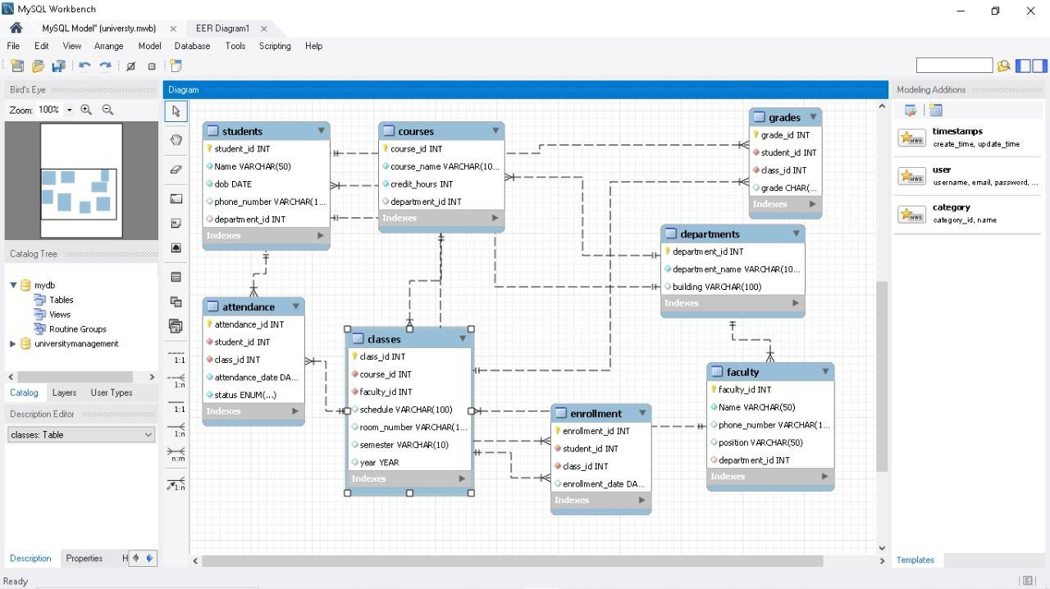

RESULT:
Thus the queries are executed successfully and university database schema is created.

Exercise 2

Create employee database with key constraints

AIM :

The aim of this database schema is to store and manage information about employees with key constraints using SQL queries.

Procedures :

Step 1: Create Database

Create database empdb;

Step 2: Use Database.
use empdb;

Step 3: Create Tables of Departments and Employees

CREATE TABLE Departments (
DepartmentID INT PRIMARY KEY,
DepartmentName VARCHAR(100) NOT NULL UNIQUE
);
CREATE TABLE Employees (
EmployeeID INT PRIMARY KEY,
FirstName VARCHAR(50) NOT NULL,
LastName VARCHAR(50) NOT NULL,
Email VARCHAR(100) NOT NULL UNIQUE,
Phone VARCHAR(15),
HireDate DATE NOT NULL,
Salary DECIMAL(10, 2),
DepartmentID INT,
CONSTRAINT fk_Department FOREIGN KEY (DepartmentID) REFERENCES Departments(DepartmentID)
);

STEP 4: Insert values into Department and Employees
INSERT INTO Departments (DepartmentID, DepartmentName)
VALUES
(1, 'HR'),
(2, 'Finance'),
(3, 'IT');

INSERT INTO Employees (EmployeeID, FirstName, LastName, Email, Phone, HireDate, Salary, DepartmentID)
VALUES
(101, 'Alice', 'Johnson', 'alice.johnson@example.com', '555-1234', '2023-01-15', 60000, 1),
(102, 'Bob', 'Smith', 'bob.smith@example.com', '555-5678', '2022-06-01', 75000, 3),
(103, 'Charlie', 'Brown', 'charlie.brown@example.com', '555-8765', '2024-03-20', 50000, 2);

STEP 5: Display Tables
SELECT * FROM Employees;
SELECT * FROM Departments ;

STEP 6 : Alter Tables
UPDATE Employees
SET Salary = 80000
WHERE EmployeeID = 102;
UPDATE Employees
SET DepartmentID = 3
WHERE EmployeeID = 103;
OUTPUT

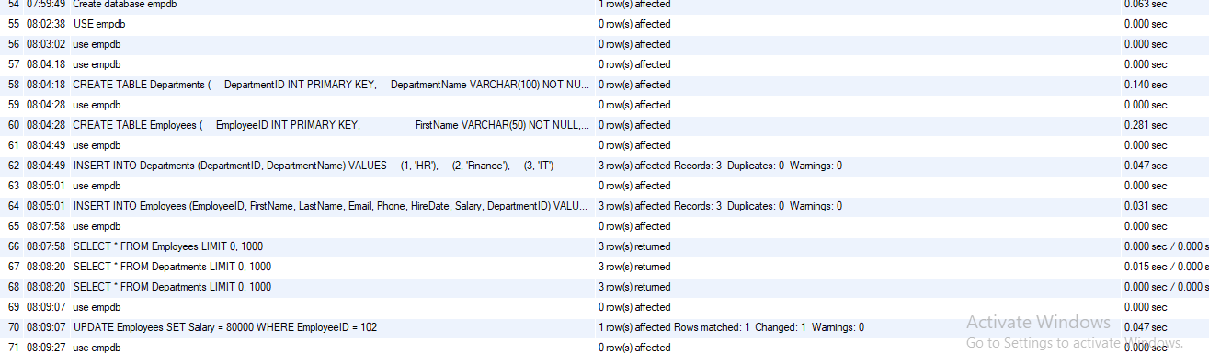

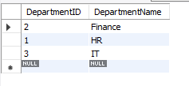

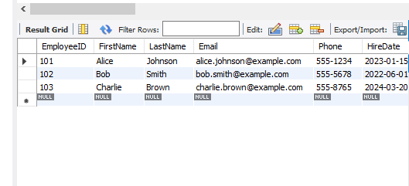

RESULT:
Thus the queries are executed successfully and employee database with key constraints was created.

Exercise 3

Create ER Model University Database

AIM :

The aim is to create University database ER model using MYSQL workbench.

Procedures :

Step 1. Open MySQL Workbench
- Launch MySQL Workbench.
- Create a new model by selecting File > New Model.
- Click Add Diagram to create a new EER Diagram.

Step 2. Add Tables for Each Entity
- From the vertical toolbar, drag the Table icon into the canvas for each entity:
  - Student
  - Course
  - Department
  - Instructor
  - Enrollment
  - Classroom
  - Schedule
Identify Entities and Their Attributes
Entity | Attributes
Student | StudentID (PK), FirstName, LastName, DateOfBirth, Email (Unique), EnrollmentDate
Course | CourseID (PK), CourseName, Credits, DepartmentID (FK)
Department | DepartmentID (PK), DepartmentName
Instructor | InstructorID (PK), FirstName, LastName, Email (Unique), DepartmentID (FK)
Enrollment | EnrollmentID (PK), StudentID (FK), CourseID (FK), EnrollmentDate, Grade
Classroom | ClassroomID (PK), Building, RoomNumber, Capacity
Schedule | ScheduleID (PK), CourseID (FK), InstructorID (FK), ClassroomID (FK), DayOfWeek, StartTime, EndTime

Step 3. Define Columns and Keys for Each Table
- Double-click each table to open the table editor.
- Add columns according to the attributes planned.
- For each table:
  - Set the primary key (PK) by checking the PK checkbox next to the relevant attribute (e.g., StudentID).
  - Set unique constraints for unique fields (e.g., Email in Student and Instructor).

Step 4. Create Foreign Key Relationships
- Still in the table editor, go to the Foreign Keys tab.
- Create foreign keys by linking attributes to the referenced table’s primary key.
  - Example: In Course, set DepartmentID as a foreign key referencing Department.DepartmentID.
  - Similarly set foreign keys for Enrollment (StudentID, CourseID), Instructor (DepartmentID), Schedule (CourseID, InstructorID, ClassroomID).

Step 5. Use Relationship Tools to Connect Tables Visually
- Use the One-to-Many or Many-to-Many relationship tools from the toolbar to visually link the tables.
- For many-to-many relationships (like Student-Course), ensure you use the associative entity Enrollment.
DEFINE relationship
- Department has many Courses and many Instructors.
- Student enrolls in many Courses (via Enrollment).
- Course is taught by many Instructors (via Schedule).
- Course scheduled in a Classroom.
- Instructor belongs to one Department.

Step 6. Save and Export
- Save your model regularly (File > Save).
- Export your diagram as an image or PDF using File > Export > Export as PNG/PDF if you want to share or print the ER diagram.

OUTPUT

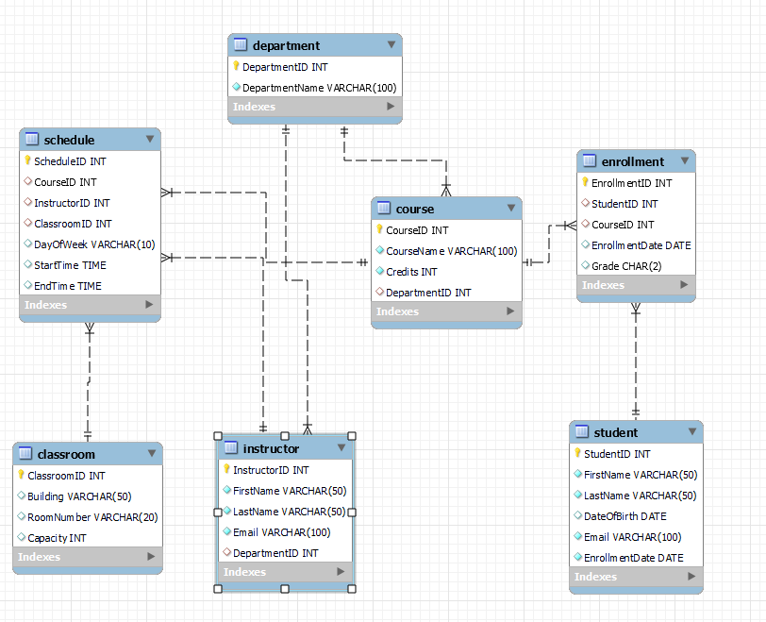

RESULT:

Thus ER model for University database is created successfully using MYSQL workbench.
Exercise 4
Implementing DDL and DML Commands
AIM :
To understand and implement Data Definition Language (DDL) and Data Manipulation Language (DML) commands using SQL.
Procedures :
DDL (Data Definition Language)
Commands used to define and modify database structure.
Examples:
- CREATE
- ALTER
- DROP
- TRUNCATE
DML (Data Manipulation Language):
Commands used to manipulate data in tables.
Examples:
- INSERT
- UPDATE
- DELETE
A. DDL Commands (Data Definition Language)

Step 1: Create a Table
Create a table named Students with fields for student details.
CREATE TABLE Students (
StudentID INT PRIMARY KEY,
Name VARCHAR(50),
Age INT,
Department VARCHAR(30)
);

Step 2: Alter the Table
Add a new column Email to the Students table.
ALTER TABLE Students
ADD Email VARCHAR(50);

Step 3: Truncate the Table
Remove all records from the Students table, keeping its structure.
TRUNCATE TABLE Students;

Step 4: Drop the Table
Permanently delete the Students table from the database.
DROP TABLE Students;

B. DML Commands (Data Manipulation Language)

Step 5: Insert Data into the Table
Insert a record for a student into the Students table.
INSERT INTO Students (StudentID, Name, Age, Department, Email)
VALUES (1, 'John Doe', 20, 'CSE', 'john@example.com');

Step 6: Retrieve Data from the Table
Display all records from the Students table.
SELECT * FROM Students;

Step 7: Update a Record
Update the email address of the student with StudentID = 1.
UPDATE Students
SET Email = 'john.doe@college.com'
WHERE StudentID = 1;

Step 8: Delete a Record
Delete the record of the student with StudentID = 1.
DELETE FROM Students
WHERE StudentID = 1;

OUTPUT:
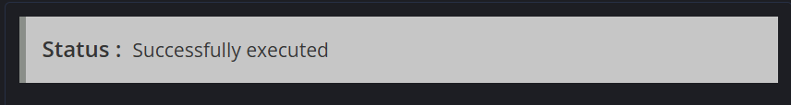
RESULT:
Thus the SQL commands for managing database schema (DDL) and manipulating records (DML) are executed successfully.

Exercise 5
Implement DCL,TCL Commands
AIM :
To understand and implement DCL and TCL commands using SQL for managing access permissions and transactions using SQL.
Procedures :
DCL – Data Control Language
Used to control access to data in a database.
Common commands:
- GRANT – gives privileges to users
- REVOKE – removes privileges from users
TCL – Transaction Control Language
Used to manage transactions in a database.
Common commands:
- COMMIT – saves the transaction permanently
- ROLLBACK – undoes changes since the last COMMIT
- SAVEPOINT – creates a point within a transaction for partial rollbacks
A. DCL Commands

Step 1: Create a User (syntax may vary depending on RDBMS)
CREATE USER 'student1'@'localhost' IDENTIFIED BY 'password123';

Step 2: Grant Privileges
Grant permissions to the user to access a specific table.
GRANT SELECT, INSERT, UPDATE ON empdb.Employees TO 'student1'@'localhost';

Step 3: Revoke Privileges
Revoke the granted permissions.
REVOKE INSERT, UPDATE ON empdb.Employees FROM 'student1'@'localhost';
B. TCL Commands

Step 4: Start a Transaction (optional depending on system)
START TRANSACTION;

Step 5: Insert Data into a Table
Insert a new employee (example assumes Employees table exists).
INSERT INTO Employees (EmployeeID, FirstName, LastName, Email, Phone, HireDate, Salary, DepartmentID)
VALUES (104, 'David', 'Lee', 'david.lee@example.com', '555-1111', '2025-08-03', 62000, 2);

Step 6: Create a Savepoint
Create a rollback point.
SAVEPOINT sp1;

Step 7: Update a Record
Update the inserted employee's salary.
UPDATE Employees
SET Salary = 65000
WHERE EmployeeID = 104;

Step 8: Rollback to Savepoint
Undo the salary update, but keep the insert.
ROLLBACK TO sp1;

Step 9: Commit the Transaction
Make all changes permanent.
COMMIT;

Step 10: Full Rollback Example
If no COMMIT is done, you can rollback all changes:
ROLLBACK;

OUTPUT:
RESULT:
Thus, DCL and TCL commands were executed successfully for managing database security and transaction control.

Exercise 6
Implement SQL sub queries, Joins and Clauses
AIM :
To implement SQL subqueries, various types of joins, and commonly used clauses for effective data retrieval and management.
Procedures :

Subqueries:
A subquery is a query nested inside another query.
Types:
- Single-row subquery
- Multi-row subquery
- Correlated subquery
Joins:
Used to retrieve data from multiple tables based on a related column.
Types:
- INNER JOIN
- LEFT JOIN (or LEFT OUTER JOIN)
- RIGHT JOIN (or RIGHT OUTER JOIN)
- FULL JOIN (may not be supported in all DBMSs)
- SELF JOIN

Clauses:
SQL clauses filter, sort, and group query results. Common clauses include:
- WHERE
- GROUP BY
- HAVING
- ORDER BY
- LIMIT

Tables for Practice:
Departments
CREATE TABLE Departments (
DepartmentID INT PRIMARY KEY,
DepartmentName VARCHAR(100)
);
Employees
CREATE TABLE Employees (
EmployeeID INT PRIMARY KEY,
FirstName VARCHAR(50),
LastName VARCHAR(50),
Salary DECIMAL(10, 2),
DepartmentID INT,
FOREIGN KEY (DepartmentID) REFERENCES Departments(DepartmentID)
);

INSERT INTO Departments
INSERT INTO Departments (DepartmentID, DepartmentName)
VALUES
(1, 'HR'),
(2, 'Finance'),
(3, 'IT'),
(4, 'Marketing');
INSERT INTO Employees
INSERT INTO Employees (EmployeeID, FirstName, LastName, Salary, DepartmentID)
VALUES
(101, 'Alice', 'Johnson', 55000.00, 1),
(102, 'Bob', 'Smith', 72000.00, 3),
(103, 'Charlie', 'Brown', 48000.00, 2),
(104, 'David', 'Lee', 65000.00, 3),
(105, 'Eva', 'Green', 51000.00, 4),
(106, 'Frank', 'Miller', 75000.00, 2);
A. Subqueries

Step 1: Subquery in WHERE clause
Get employees earning more than the average salary.
SELECT * FROM Employees
WHERE Salary > (SELECT AVG(Salary) FROM Employees);

Step 2: Subquery in FROM clause
Get department-wise average salary using a subquery.
SELECT DepartmentID, AvgSalary
FROM (SELECT DepartmentID, AVG(Salary) AS AvgSalary FROM Employees GROUP BY DepartmentID) AS DeptAvg;

B. Joins

Step 3: INNER JOIN
Get employee details with their department names.
SELECT e.EmployeeID, e.FirstName, e.LastName, d.DepartmentName
FROM Employees e
INNER JOIN Departments d ON e.DepartmentID = d.DepartmentID;

Step 4: LEFT JOIN
Show all employees and their departments, even if the department is NULL.
SELECT e.EmployeeID, e.FirstName, d.DepartmentName
FROM Employees e
LEFT JOIN Departments d ON e.DepartmentID = d.DepartmentID;

Step 5: RIGHT JOIN
Show all departments and employees, even if no employees are in a department.
SELECT e.EmployeeID, e.FirstName, d.DepartmentName
FROM Employees e
RIGHT JOIN Departments d ON e.DepartmentID = d.DepartmentID;

Step 6: SELF JOIN
Find pairs of employees from the same department.
SELECT e1.FirstName AS Emp1, e2.FirstName AS Emp2, e1.DepartmentID
FROM Employees e1
JOIN Employees e2 ON e1.DepartmentID = e2.DepartmentID AND e1.EmployeeID <> e2.EmployeeID;

C. SQL Clauses

Step 7: WHERE Clause
Get employees from the IT department.
SELECT * FROM Employees
WHERE DepartmentID = 3;

Step 8: GROUP BY Clause
Find total salary paid in each department.
SELECT DepartmentID, SUM(Salary) AS TotalSalary
FROM Employees
GROUP BY DepartmentID;

Step 9: HAVING Clause
Departments where total salary exceeds 1,00,000.
SELECT DepartmentID, SUM(Salary) AS TotalSalary
FROM Employees
GROUP BY DepartmentID
HAVING SUM(Salary) > 100000;

Step 10: ORDER BY Clause
Display all employees in descending order of salary.
SELECT * FROM Employees
ORDER BY Salary DESC;

Step 11: LIMIT Clause (MySQL)
Fetch top 3 highest paid employees.
SELECT * FROM Employees
ORDER BY Salary DESC
LIMIT 3;

OUTPUT:
RESULT:
Thus, SQL subqueries, joins, and clauses were implemented successfully using structured SQL queries.

